MIND STORM SOFTWARE PVT LTD
Hands-On Exercise – ex04.doc
Objective
This exercise shows how to use built in Intents in Android. It means that when we have to perform common operations like dial a phone number, send a SMS, send an email, view a web url in a browser, then there are already existing applications on the Android device that can do it for us. All we need to do then is to specify our intent (what we want to do) and Android will choose the right program and launch it.
Assumptions
- Development Environment for Android (Java SDK, Eclipse, Android SDK) has been setup successfully.
- You are familiar with using Eclipse.
- Android SDK 2.3.3 is available and Android Virtual Devices are already created.
- Start the Android Virtual Device to save time.
  - Click on Window → Android SDK and AVD Manager.
  - Select an Android 2.3.3 compatible AVD and click on Start
  - Select Scale display to real size and provide a Screen Size (in) as 5 inches or any other appropriate size for your development machine.
Step by Step Instructions
Step 1 – Create the Android Project
- Create a new project. Click on File→New → Android Project
- Enter Project Name as ex04 .Click on Next.
- Select the Build Target as Android 2.3.3 .Click on Next.
- Enter Package Name as com.mindstorm.ex04
- In Create Activity, overwrite the default Activity name with the following name : MainActivity
- Click on Finish
- (Optional): Verify that the Project runs in your Emulator by Right-click the Project and Run As → Android Application
Step 2 – Code the Main Activity
- Define the Layout for Main Activity. This will consist of a few buttons which will launch the different applications which correspond to the Intent.
Go to res/layout folder. Modify main.xml to contain the following (You can simply copy this).
<?xml version="1.0" encoding="utf-8"?>
<LinearLayout xmlns:android="http://schemas.android.com/apk/res/android"
android:orientation="vertical"
android:layout_width="fill_parent"
android:layout_height="fill_parent"
>
<TextView android:text="Built In Intents" android:gravity="center_horizontal" android:id="@+id/textView1" android:textAppearance="?android:attr/textAppearanceLarge" android:layout_width="fill_parent" android:layout_height="wrap_content"></TextView>
<Button
android:id="@+id/btn_makecalls1"
android:layout_width="fill_parent"
android:layout_height="wrap_content"
android:text="Action Dial" />
<Button
android:id="@+id/btn_makecalls2"
android:layout_width="fill_parent"
android:layout_height="wrap_content"
android:text="Action Call" />
<Button
android:id="@+id/btn_sendsms"
android:layout_width="fill_parent"
android:layout_height="wrap_content"
android:text="Send SMS" />
<Button
android:id="@+id/btn_sendemail"
android:layout_width="fill_parent"
android:layout_height="wrap_content"
android:text="Send Email"/>
</LinearLayout>

- Go to src → com.mindstorm.ex04 and open MainActivity.java file. Modify the MainActivity.java code as shown below:
package com.mindstorm.ex04;

import android.app.Activity;
import android.content.Intent;
import android.net.Uri;
import android.os.Bundle;
import android.view.View;
import android.view.View.OnClickListener;
import android.widget.Button;

public class MainActivity extends Activity {
Button b1, b2, b3, b4;

/** Called when the activity is first created. */
@Override
public void onCreate(Bundle savedInstanceState) {
super.onCreate(savedInstanceState);
setContentView(R.layout.main);
//---Action Dial button---
b1 = (Button) findViewById(R.id.btn_makecalls1);
b1.setOnClickListener(new OnClickListener()
{
public void onClick(View arg0){
Intent i = new Intent(android.content.Intent.ACTION_DIAL,Uri.parse("tel:+651234567"));
startActivity(i);
}
});

//---Action Call button
b2 = (Button) findViewById(R.id.btn_makecalls2);
b2.setOnClickListener(new OnClickListener()
{
public void onClick(View arg0){
Intent i = new Intent(android.content.Intent.ACTION_CALL,Uri.parse("tel:+651234567"));
startActivity(i);
}
});

//---Send SMS button
b3 = (Button) findViewById(R.id.btn_sendsms);
b3.setOnClickListener(new OnClickListener()
{
public void onClick(View arg0){
Intent i = new Intent(android.content.Intent.ACTION_VIEW);
i.putExtra("address", "9820300784;9821060381");
i.putExtra("sms_body", "Hi. I am currently attending the Android Workshop.");
i.setType("vnd.android-dir/mms-sms");
startActivity(i);
}
});
//---Send Email button
b4 = (Button) findViewById(R.id.btn_sendemail);
b4.setOnClickListener(new OnClickListener()
{
public void onClick(View arg0){
Intent emailIntent = new Intent(Intent.ACTION_SEND);

String[] to = {"romin.k.irani@gmail.com","romin.irani@mindstormsoftware.com"};
emailIntent.putExtra(Intent.EXTRA_EMAIL, to);

//String[] cc = carbonCopies;
//emailIntent.putExtra(Intent.EXTRA_CC, cc);

emailIntent.putExtra(Intent.EXTRA_SUBJECT, "Reminder For Android Workshop");

emailIntent.setType("text/plain");
emailIntent.putExtra(Intent.EXTRA_TEXT, "Please note that the Android Workshop is going to be held on 6th October 2012.");

startActivity(Intent.createChooser(emailIntent, "Send Email via..."));
}
});
}
}
Step 3 – Add the Permission in Manifest
Go to the AndroidManifest.xml file and add the following permission. This is needed when you use the ACTION_CALL. Add this element as a child of the <manifest> element and outside of the <application> element.
<uses-permission android:name="android.permission.CALL_PHONE"></uses-permission>
Step 4 – Run the Example
- Right Click the Project in Eclipse.
- Select Run As → Android Application
- (Optional): If you have multiple compatible AVDs running, select the correct AVD. In our case it is the 2.3.3 AVD.

You should see the MainActivity screen come up.

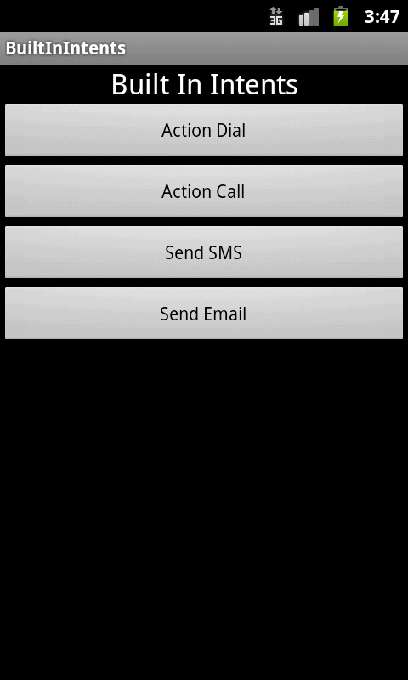

Clicking on any of the buttons will result in the application specifying an Intent where it only specifies the Intent Action along with data. For e.g. if you click the Make Calls button, it will launch the Call Application as shown below:

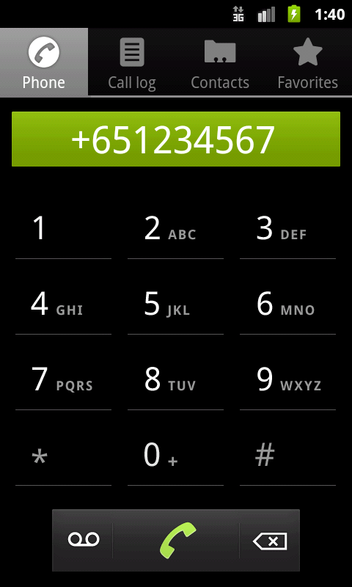
Summary
This hands-on exercise demonstrated how to use Built-In Intents in Android. We learnt about the following built-in intents in Android:
- android.content.Intent.ACTION_DIAL
- android.content.Intent.ACTION_CALL
- android.content.Intent.ACTION_VIEW
- android.content.Intent.ACTION_SEND
More Reference:
- For built in Intents of Google Applications : http://developer.android.com/guide/appendix/g-app-intents.html
- For more Actions available in Android : http://developer.android.com/guide/topics/intents/intents-filters.html

